
CHITKARA INSTITUTE OF ENGINEERING AND TECHNOLOGY

Smily
#314, Preet Nagar, Firozpur City
+91-9872762231
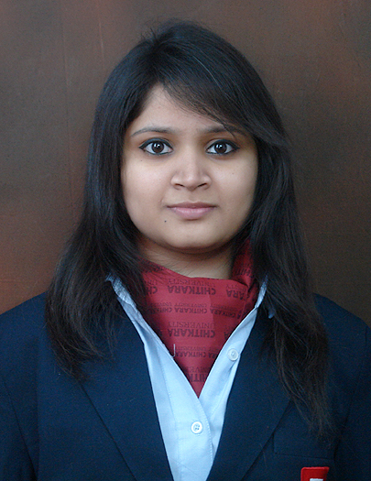

smily.arora96@gmail.com

EDUCATION:

Qualification/Degree | School/College | University or Board | CGPA | Year
B. Tech. (CSE) | Chitkara Institute of Engg. & Tech. | Chitkara University | 8.85 | 2014-2018
Class XII | Guru Nanak Sr. Sec, Firozpur | P.S.E.B | 83.33% | 2013-2014
Class X | DCM International, Firozpur | C.B.S.E | 10 | 2011-2012

PROJECTS & TRAININGS:.

- Graphic Den (Jan 2016 - Apr 2016)
GraphicDen was a project made for data visualization and analyzing data according to the user’s spreadsheet. Currently bar graphs, line graphs and pie charts are supported in 2-D
Technologies used: Front End: HTML, CSS, Bootstrap. Back End: Django

- IIT Mumbai Robotics Workshop(Chandigarh) Oct 2014 - Oct 2014
Workshop on mobile robotics using Aurdino. learned to program a micro controller and made projects such as line following bots and light following bots.
Technology used: Microcontrollers

- CO Analyzer (Jan 2015 - Apr 2015)
Carbon Monoxide analyzer made on micro-controller(Aurdino ATMega) and CO sensor module.It was used to sense the levels of CO present in air/certain environment and display readings on an attached display.
Technology used: Aurdino Microcontrollers, CO sensor.

ACHIEVEMENTS:

Academic
- Participation in SAP Lumira Hackathon held at Chitkara University(Aug 2016).
- Certification in C/C++ by Tech Square Solutions.
- Scored a CGPA of 8.85 till 2nd Year in college.
- Online Course - Programming in Scratch (June 2015)
A course of study offered by Harvey MuddX, an online learning initiative of of Harvey Mudd College through edX.
http://bit.ly/2i8nDIs
- Online Course - Computer Science 101(June 2015)
A course of study offered by Stanford University.
http://bit.ly/2jV1OcG

Cultural:
- Liaison officer (Conference staff) at Chitkara International Model United Nations, March 2015.

PROFESSIONAL SKILLS:

- Languages: C, C++, HTML, Core JAVA.
- DBMS: SQL Server (Intermediate)
- Application Software: Android Studio
- OS: Linux, Windows OS.
- Good Organizational skills.

CO-CURRICULAR ACTIVITIES:

- Attended the SAP Lumira Workshop (Hackathon) held at Chitkara University in August, 2016.
- Attended Logo making competition in Techfest(2014) and cleared first round.
- Active member of Art of Living Society and attended several workshops.

INTEREST & HOBBIES:

- Listening music
- Singing
- Helping others

(Smily)

